**Command Pattern: Assignment-2**

**Course ID:** SWE-4502

**Course Name:** Design Pattern Lab

**Name:** Farzana Tabassum

**ID:** 180042119

**Department:** CSE (SWE)

**Semester:** Winter (5th semester)

**Date:** 13/08/2021

**GitLink:** <https://github.com/farzana-snigdha/dpatterna/tree/command-pattern>

# Code implementation

**command-lightChanges.ts**

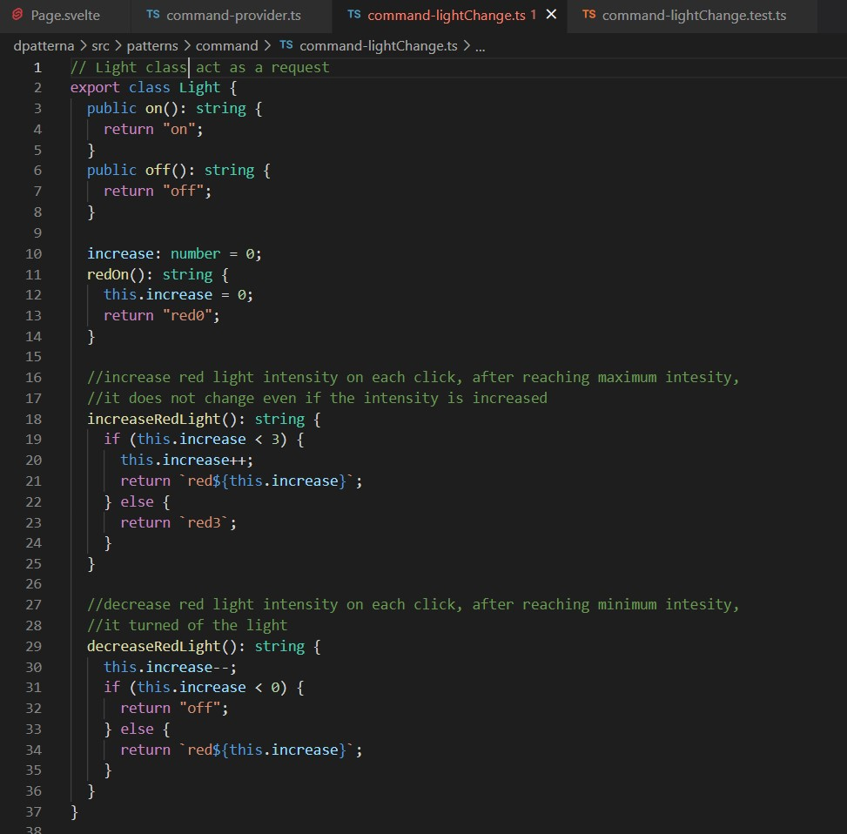

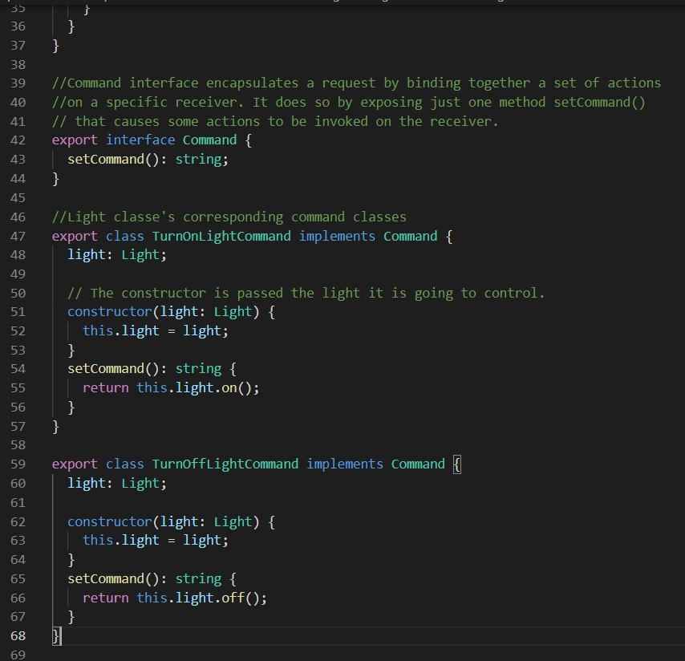

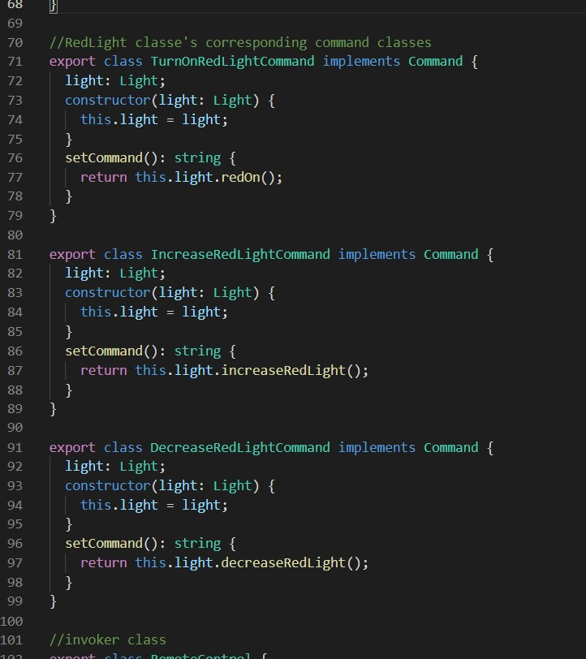

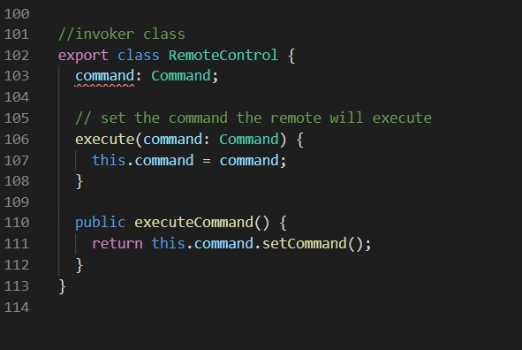

**command-provider.ts**

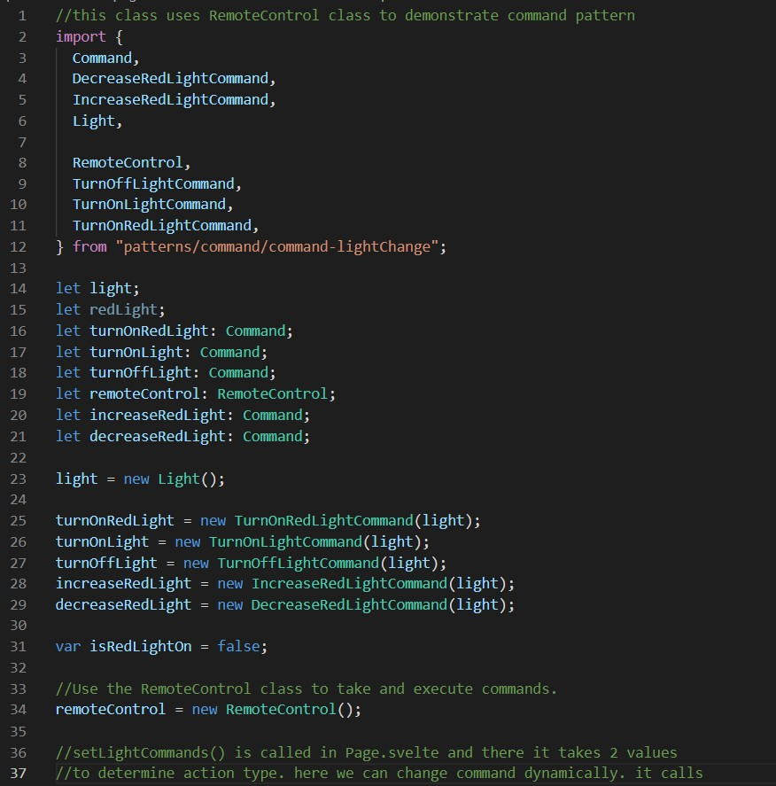

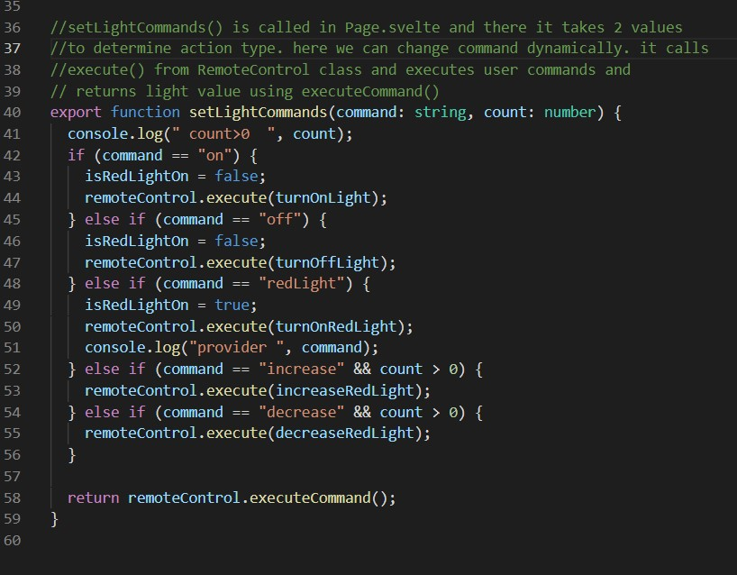

**page.svelte**

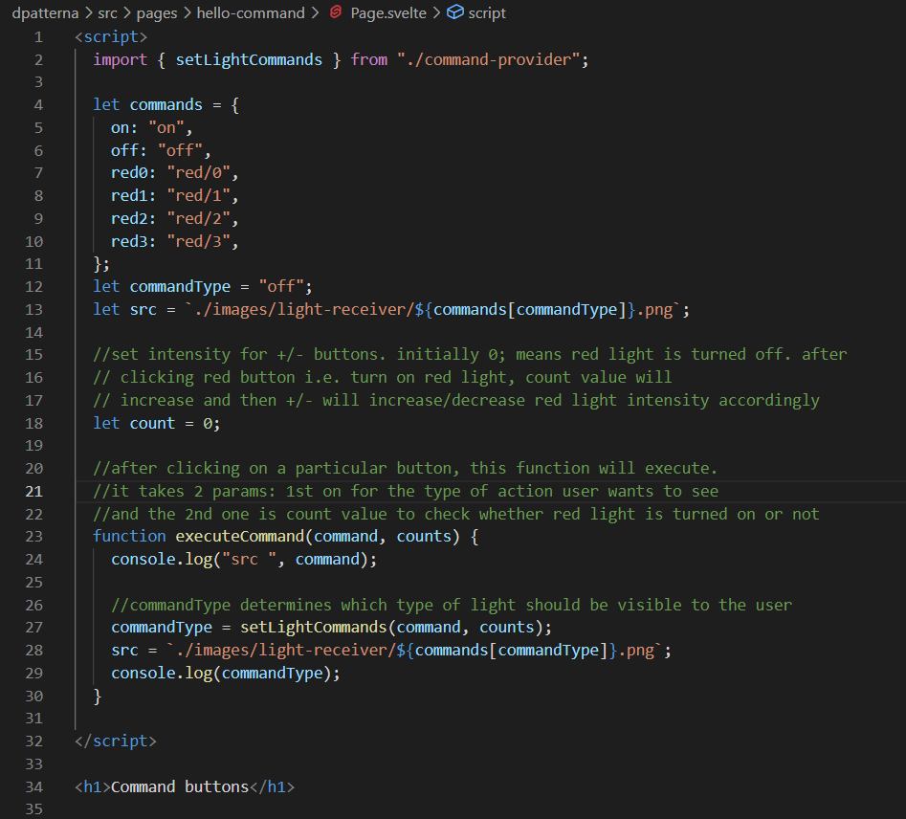

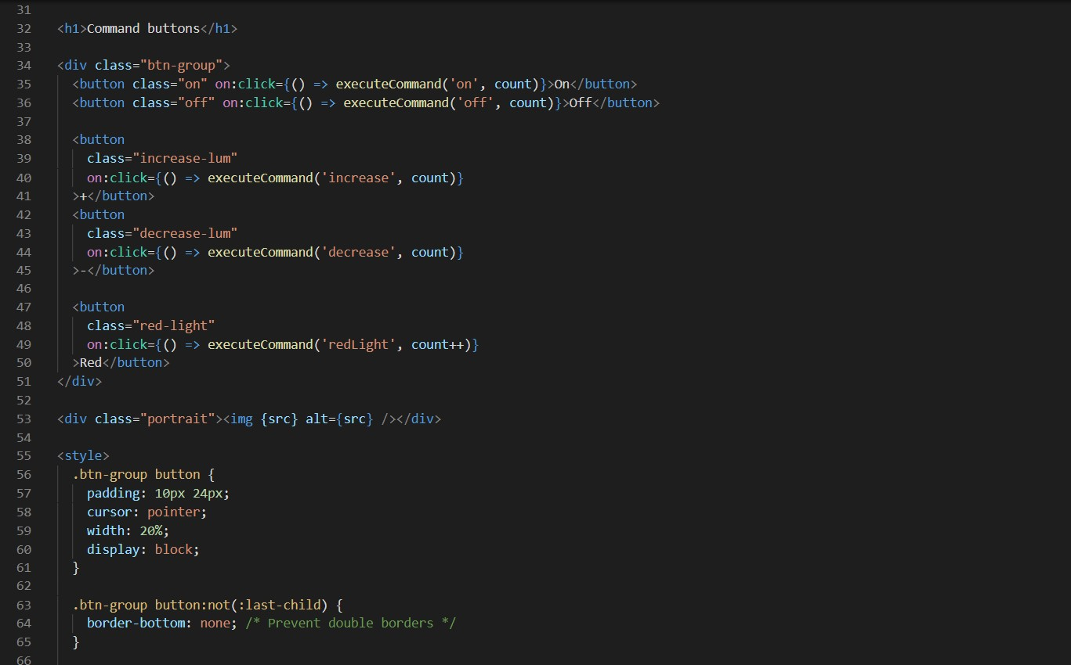

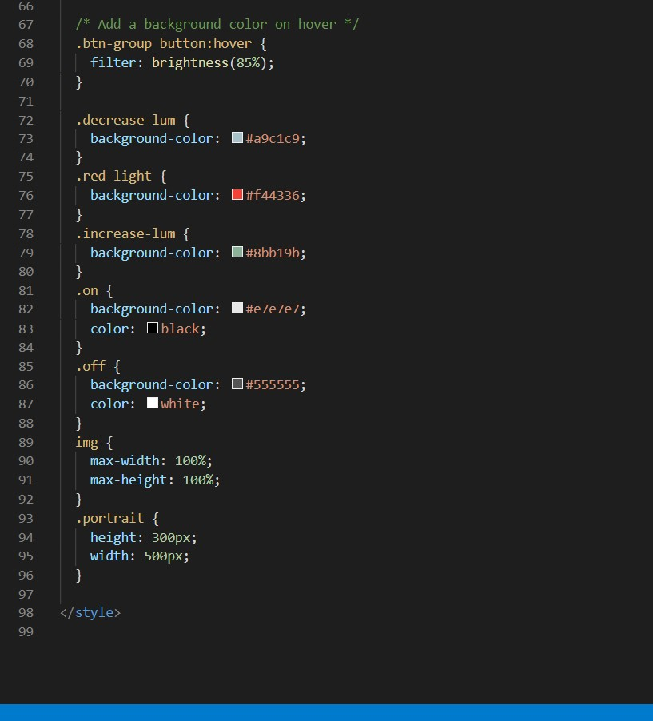

# Unit tests

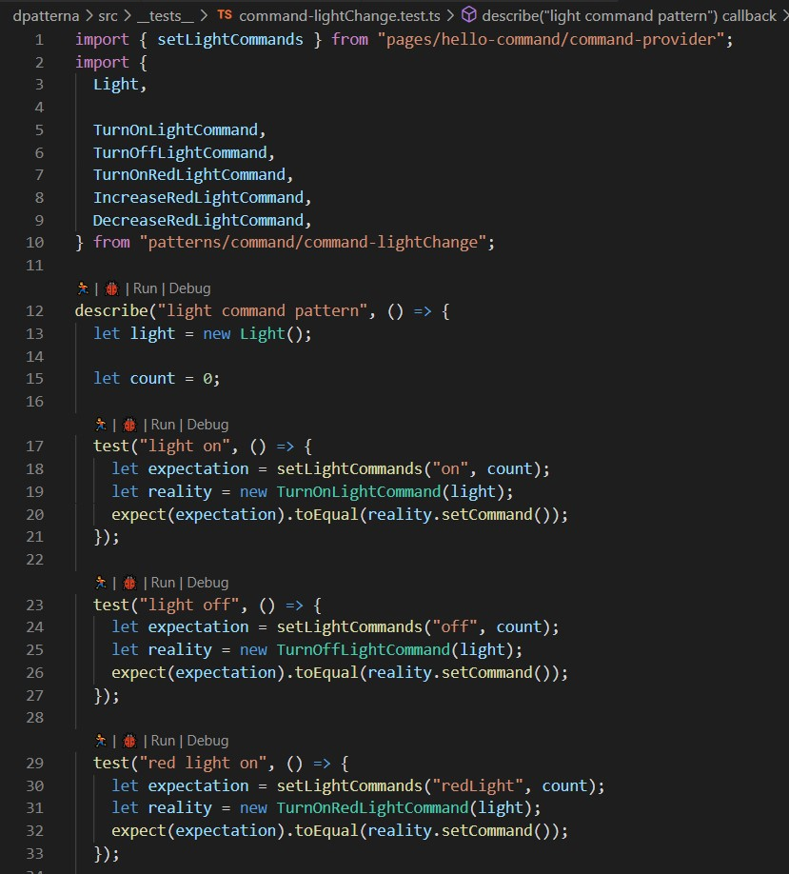

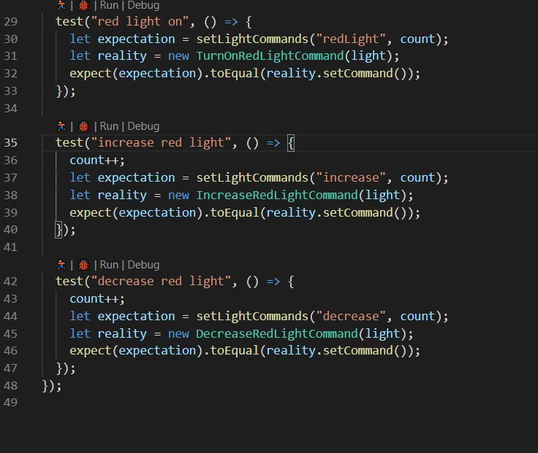

# UML diagram

